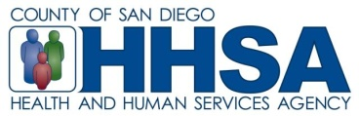
To: CYF Day Treatment Providers Date: May 5, 2016

From: Helen Kobold, LMFT, QM Specialist

Re: Day Treatment Programs – Required Document Submission

Dear Day Treatment Providers,

QM is requesting that Day Treatment documents be submitted for review period FY 16-17. Documents to be submitted are: Program Description, Group Description and Schedule. All required documents must be submitted by June 1, 2016.

As a reminder, if there are any changes to Day Treatment documents during the year, documents must be submitted for review and approval.

Below is a summary of the required standards:
- Program Description, there is a minor change: (see comment in bold)
- 500-700 words
- Brief background, history and include identifying the parent organization, if applicable
- Target population
- Have a description of your CRISIS PROTOCOL.
- Services offered (include Community Meeting and how it meets criteria and other activities that may not be part of the milieu)
- What about the program makes it unique/special
- Location and address, contact manager’s name and phone number
- Name and phone number of COR

- Group Format Description: (new addition)
- Must also discuss if group is an:
  - Adjunctive
  - Skill Building
  - Process

- Schedule: (new additions)
- Must have the name and license designation of the staff
- Must have the date run across the top
  - Ex. Monday 1/1/15 Tuesday 1/2/15, etc.
- Must have the type of group it is on the schedule such as Adjunctive, Skill Building, Process

Please contact QM Specialist, Helen Kobold @ Helen.Kobold@sdcounty.ca.gov with any questions.

