More Information
Please refer to the PC 1000 Drug Diversion Program Guidelines and Participant Standards for more information.
Diversion Program Checklist  - Contact the provider listed on your referral form. If you have private insurance contact your healthcare provider.  - Schedule the intake assessment.  - Return to court for the 60-day review with a copy of your status report.  - Complete the minimum 20 hours of education or treatment, as directed.  - Return to court for your next review and/or final review 12-month hearing. Bring a copy of your participant status report or completion report.  - Violate no laws. If you are arrested or convicted of a new crime, other than a minor traffic violation, your participation in the Drug Diversion Program may be terminated and you will be referred back to court. |  |  |  | Pc 1000  drug diversion program  County of San Diego  Health and Human Services Agency, Behavioral Health Services  BHS-550 Pamphlet  07/31/2019

PC 1000 Drug Diversion Program  introduction  CA Penal Code Section 1000 (PC 1000) establishes local drug diversion programs for eligible participants who are screened by prosecutors for eligibility and referred by the court. Your drug charge will be dismissed if you: 1) successfully satisfy the requirements and complete the program, and 2) do not receive any new arrests and/or convictions. If you are arrested or convicted of a new crime, your participation in the PC 1000 program may be terminated and you will be referred back to court.  The PC 1000 program has been intentionally split into two tracks: either education or treatment. A trained clinician will assess your need for substance use disorder (SUD) treatment or education. If you have private health insurance, you will be referred to your healthcare provider. If you are eligible for Drug Medi-Cal services, you will be referred to a County treatment provider. If you are unsure whether or not you are eligible for County services, you should contact one of the participating treatment providers listed on the referral form. | 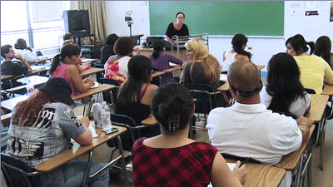 | education Track  Persons not assessed with a substance use disorder (SUD) will be placed into the Education Track. There, you must complete 20 hours of education classes to satisfy the diversion requirements.  If you enroll in the education track, your provider will submit a 1-month and 20-hour completion report to the court outlining your participation. You should retain a completion report for your records and bring it to court. You must successfully complete the 20-hour curriculum. If you do not successfully complete the education track, and are later assessed as needing SUD treatment, you may be referred to the treatment track. If you do not successfully complete the education track and do not assess as needing treatment, you will be dismissed from the program and referred back to court. |  | treatment Track  Persons assessed as having a substance use disorder (SUD) will be placed in the treatment track. You must participate in a minimum of 20 hours of treatment to satisfy PC 1000 Drug Diversion requirements. The level of care may include, but not be limited to, detoxification, outpatient services, intensive outpatient services, and/or residential drug treatment. You may also be connected with other services depending on your individual situation and needs.  If you enroll in the treatment track, your provider will submit a 1-month and 20-hour completion report to the court. You should retain copies for your records and bring them to court. You will be required to submit a status report to the court at your 12-month review hearing. If you do not successfully participate in the treatment track, you will be dismissed from the PC 1000 program. You may not enroll in the education track.

